EXP 3 HEMACHANDIRAN A
REPORTS IN ZOHO CREATOR 240701188

AIM
To build different types of reports in Zoho Creator so that the records stored in the Vehicle Service application forms can be viewed, grouped, and analysed easily.

PROCEDURE
- Log in to Zoho Creator and open the Vehicle Service application.
- Add a few sample records to each form in the application.
- Create a List / Spreadsheet report for each form to display the records in tabular format.
- Create a Kanban report grouped by a field such as Service Type or Status.
- Create a Calendar / Timeline report using a date field such as Service Date.
- Create a Map report using an address or location field.
- Create a Pivot Table and a Pivot Chart to summarise the data by fields such as Service Type, Status, or Date.
- Configure the columns, filters, and grouping for each report.
- Preview every report, confirm that the data is correct, and capture screenshots.

OUTPUT
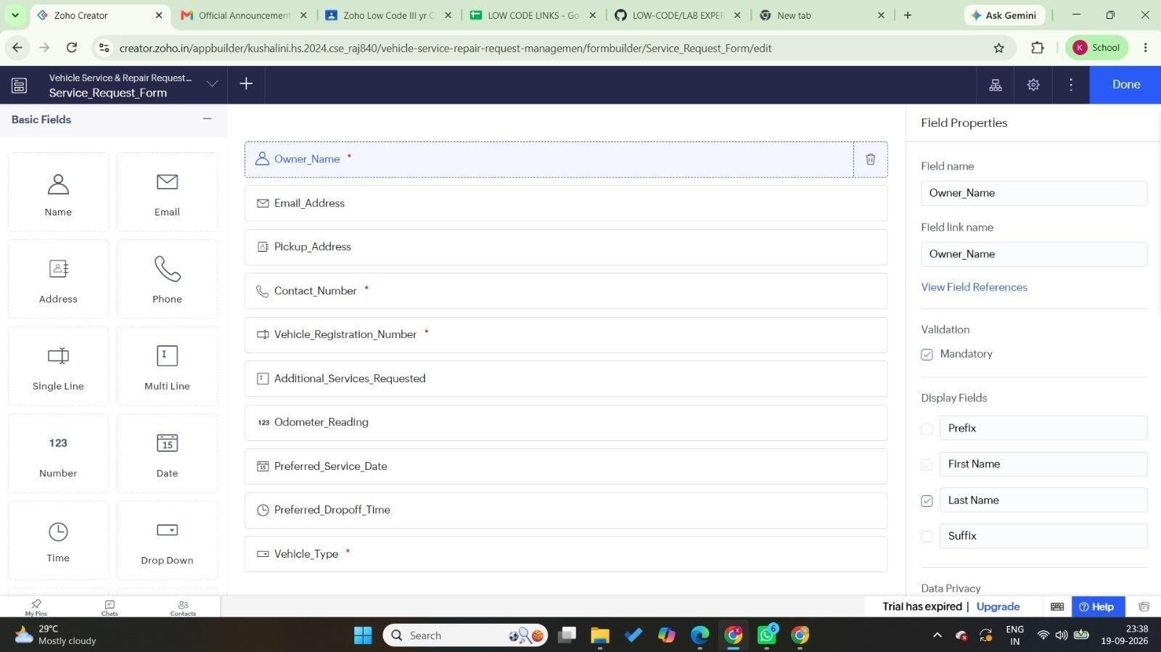
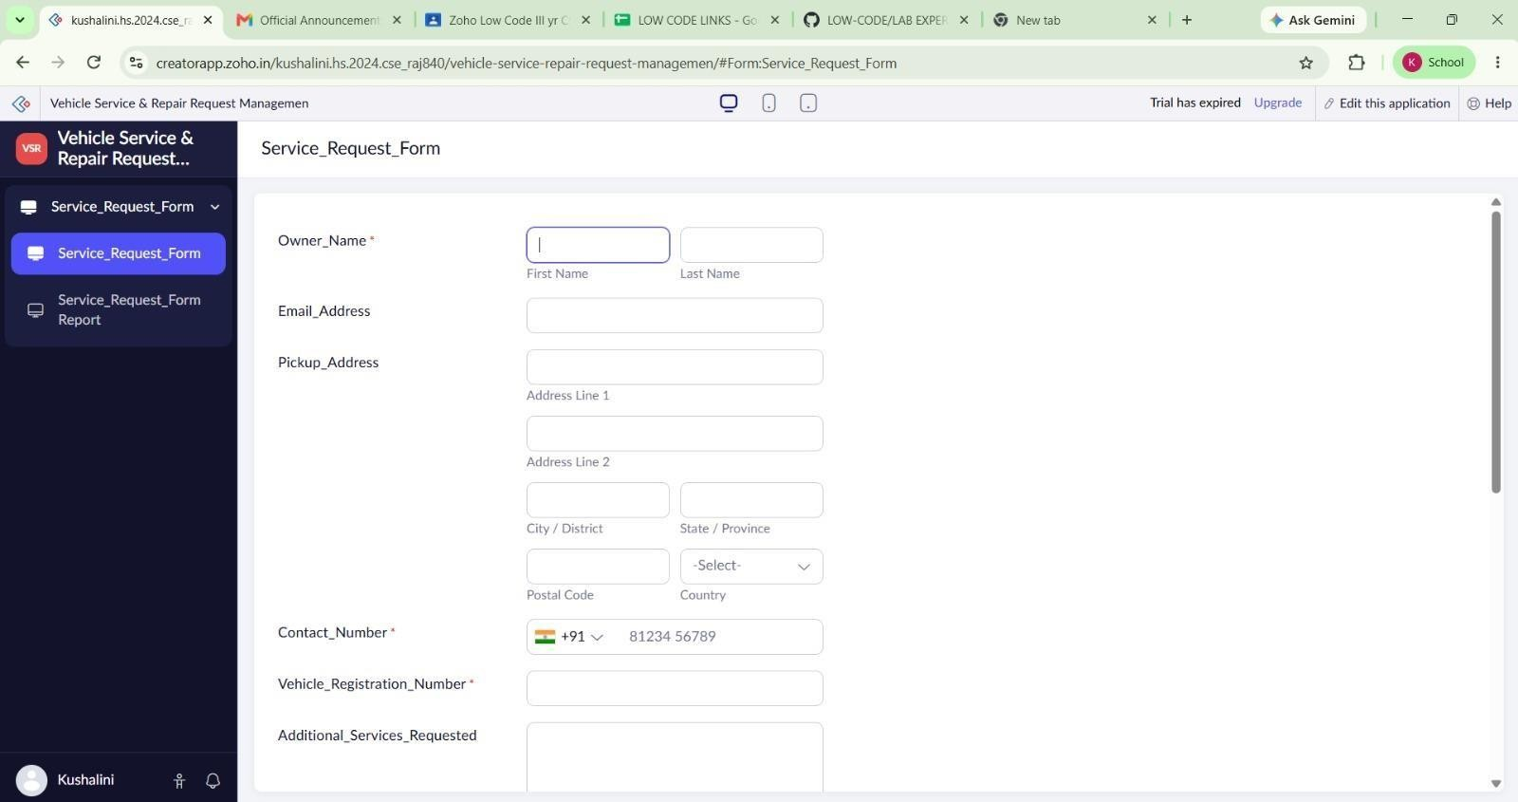

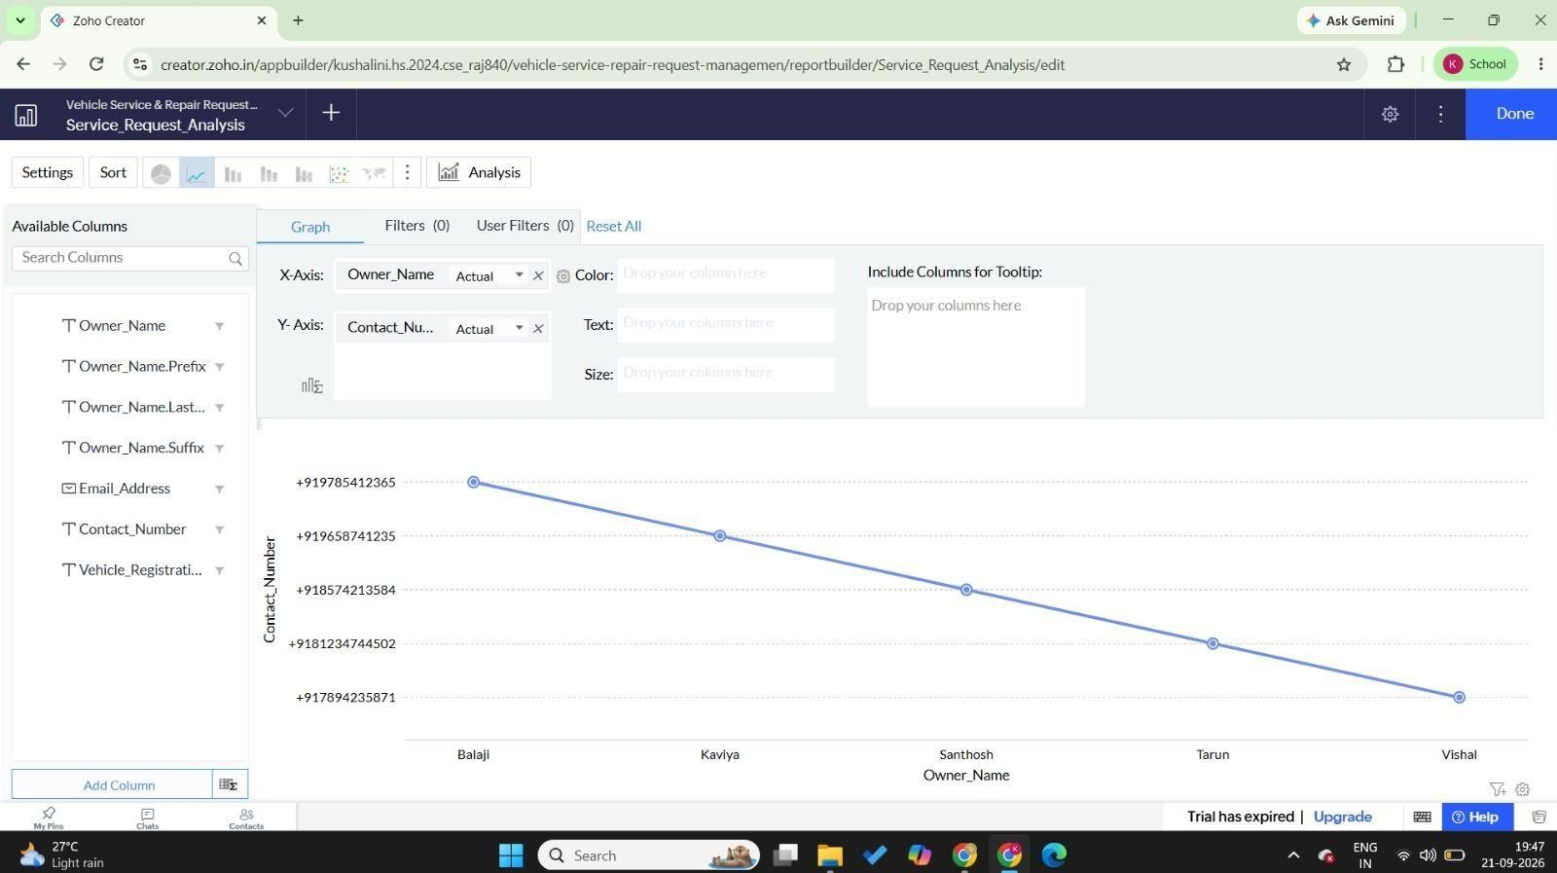
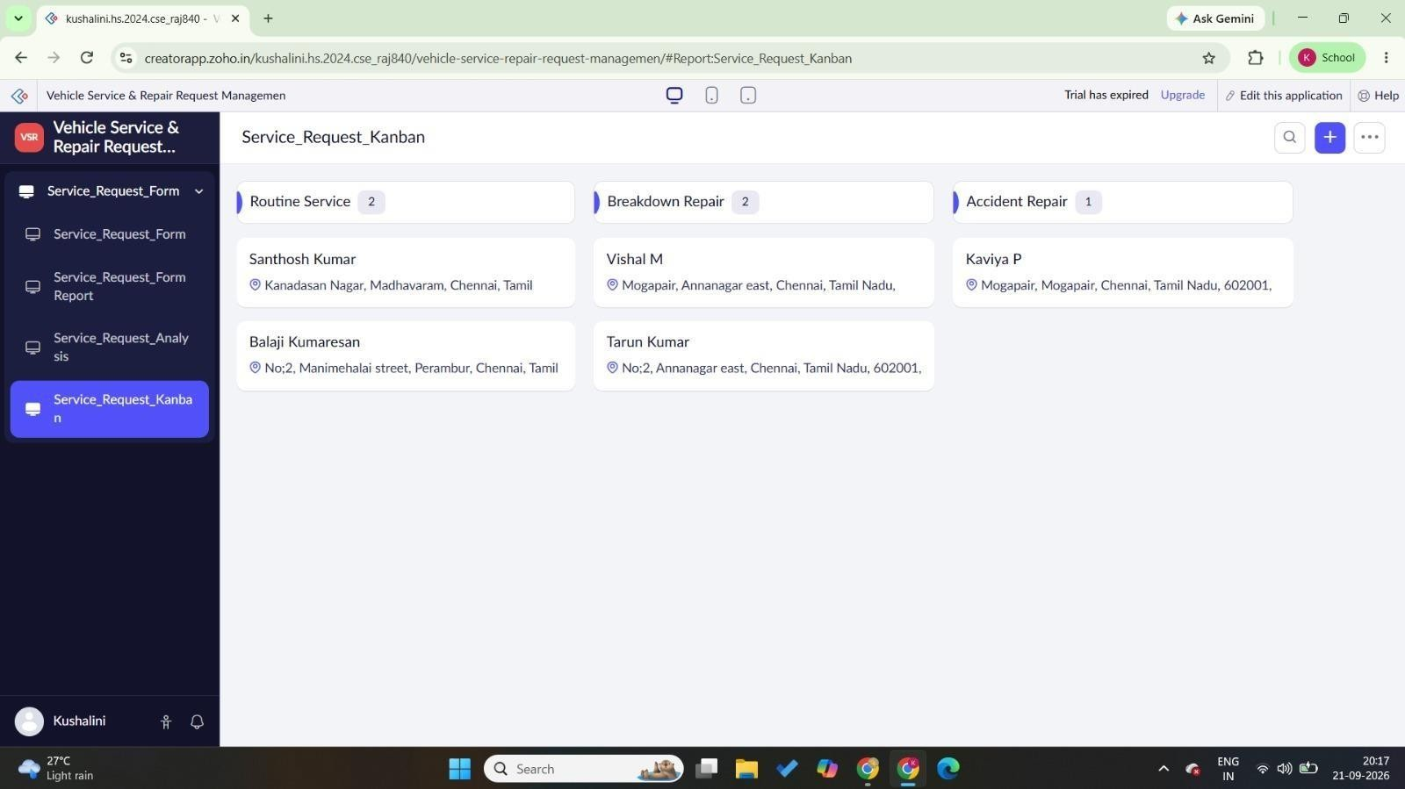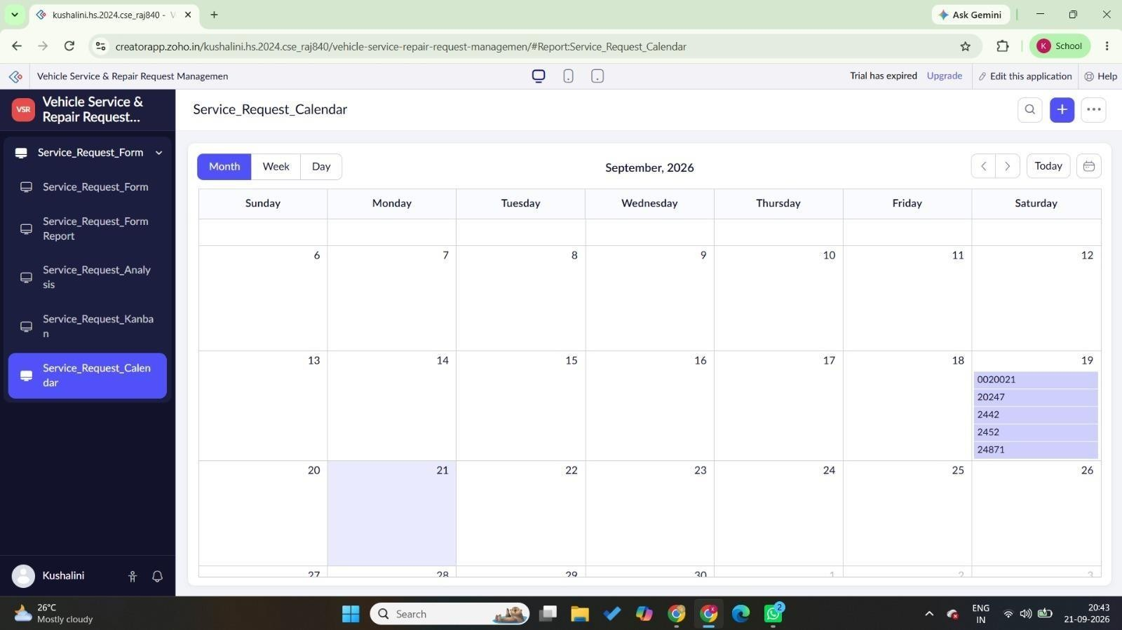
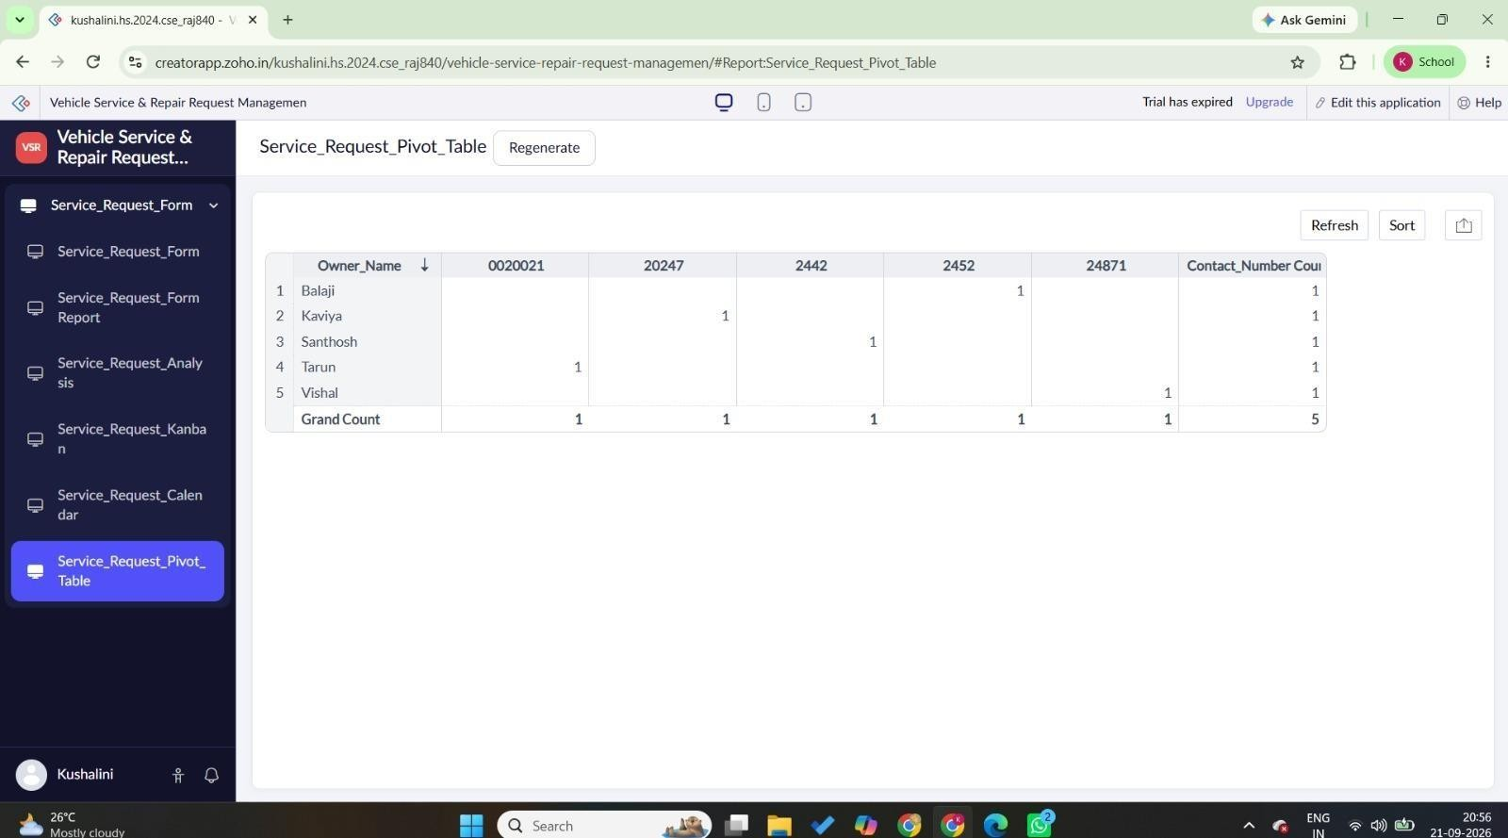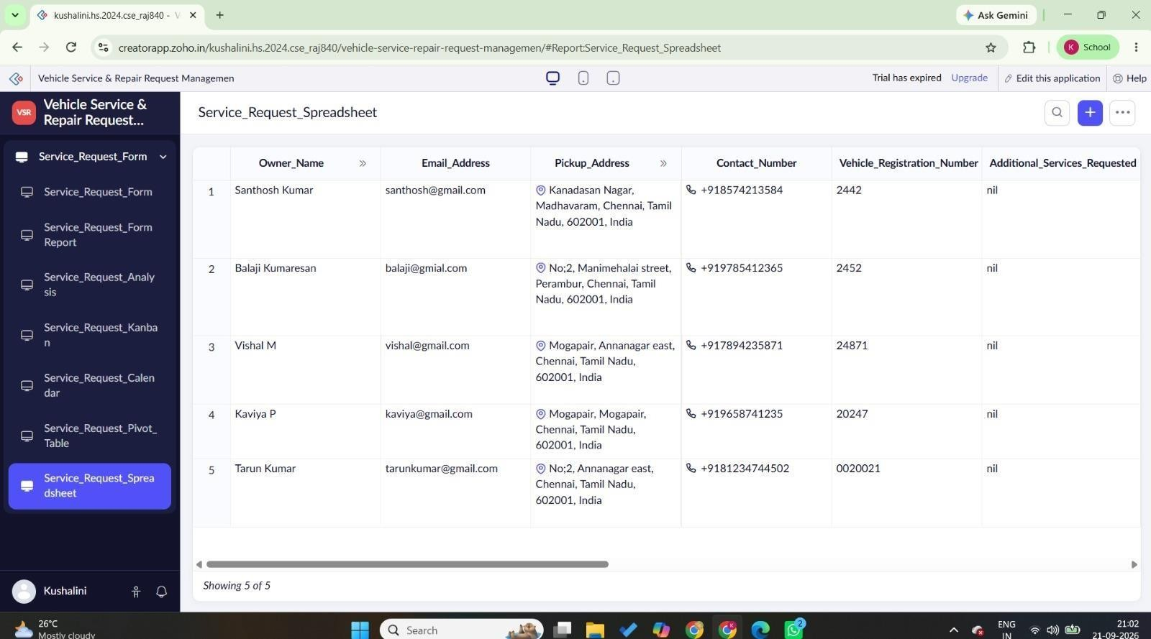

RESULT
Thus, list, kanban, calendar, map, pivot table, and pivot chart reports were successfully created from the Vehicle Service application.

